**EMERGENCY PLAN**

**Norec Training Kathmandu February 2023**

This emergency plan describes the necessary measures taken to ensure that the training is organized in a way that provides safety for our participants and ensures a proper response in case of an emergency.

In addition to the standard content we have added scenarios for a table top before departure, earthquake safety tips. The risk analysis for the training is attached in the end (in Norwegian).

Innhold

EMERGENCY TEAM 3

BEFORE DEPARTURE/PLANNING PROCEDURES: 4

DURING TRAINING: 5

LINES OF COMMUNICATION 7

OTHER CONTACT INFO 9

SOALTEE HOTEL SECURITY ROUTINES: 11

RELEVANT PHONE NUMBERS: 12

SCENARIOS TO DISCUSS PRE-DEPARTURE: 14

EARTHQUAKE SAFETY TIPS-NOREC 15

RISIKOANALYSE KATHMANDU FEBRUAR 2024 19

# EMERGENCY TEAM

|  |  |  |  |
| --- | --- | --- | --- |
| **Norec Team on site:** | | | |
| Responsible Training Officer | Andreas | +47 9xx xx xxx | Andreas@Norec.no |
| Training Officer | Eirik | +47 9xx xx xxx |  |
| Training Officer | Andrea | +47 9xx xx xxx |  |
| Training Officer | Ane | +47 9xx xx xxx |  |
| **Norec Team in Førde:** | | | |
| Main contact person: Programme Director | Margunn Indrebø Alshaikh | +47 9xx xx xxx | margunn@norec.no |

If any member of the emergency team for any reason is not able to perform their tasks, a new person must immediately be assigned the role, the emergency plan must be updated, and all team members notified.

# BEFORE DEPARTURE/PLANNING PROCEDURES:

|  |  |  |
| --- | --- | --- |
| What | Responsible | Comments |
| Security meeting. Register at [reiseregistering](https://www.reiseregistrering.no/).no  Check valid insurance. | Andreas | [Egen liste over det som skal gjennomgås i beredskapsfana på intranett](https://fredskorpset.sharepoint.com/sites/Intranett/Delte%20dokumenter/Forms/AllItems.aspx?id=%2Fsites%2FIntranett%2FDelte%20dokumenter%2FBeredskap%2Ffk%2Dnorway%2Dsecurity%2Dand%2Dhealth%2Dassessment%2D1%2Epdf&parent=%2Fsites%2FIntranett%2FDelte%20dokumenter%2FBeredskap&p=true&ga=1) |
| Assess the security situation based on MFA’s travel advice, and if necessary, in contact with the Norwegian Embassy in Kathmandu | Andreas | No specific travel advice. Moderate risk of earthquake and traffic incidents. |
| Inform the hotel of our emergency measures and get information from venue concerning their routines | Andreas/Ane | On Friday just after arrival. |
| Distribute emergency plan to all members of the Norec team with responsibilities during the event. | Andreas | First during the meeting pre-departure, and second when arrived at the hotel, together with logistical provider. |

# DURING TRAINING:

|  |  |  |
| --- | --- | --- |
|  | Responsible | Comments |
| Norec will be present at all hours at the venue and can be reached by participants when needed. This is from the first participant arrives, till the last participant has left. | Shree |  |
| There will always be a person from Norec available to assist with the transport with transportation of participants to the doctor/hospital if necessary | Shree |  |
| Participants will be informed of evacuation routines, rally points, contact information, and whom to contact in the first plenary session. | Hotel staff/ Shree | First day – Sunday 11th |
| A folder labeled “Security” including complete participant lists with relevant contact information and this emergency plan is available at all times in the Norec office at the hotel, and with the Responsible Training Officer | Andreas |  |

**GENERAL INFORMATION TO PARTICIPANTS**

In **critical** situations involving **danger to life and/or health** participants should contact (or get assistance in contacting) hotel or local authorities (police, ambulance, fire brigade) before contacting Norec staff.

In **serious** situations (**missing, criminal behavior, risk of property damage, or non-fatal injuries**) participants shall notify the nearest Norec person to jointly assess the situation.

**EMERGENCY SITUATIONS:**

In case of a critical or serious situation[1], the Responsible Training Adviser enters the role of **Crisis Manager**, and immediately calls a meeting with the Norec Team on site. In the meeting, a decision is made on necessary measures, further action, responsibility distribution, and communication lines. The Crisis Manager reports immediately after the meeting to the contact person in Førde: **Who, What, When, Where, and what measures are being made/planned.**

# LINES OF COMMUNICATION

The lines of communication will depend on the seriousness of the situation, but the general structure will be the following:

Embassy

Media

Ambulance/ Hospital

ADMINISTRATIVE ADVISER

Øystein

Participants

Local authorities

Hotel

Other

Partners

Norec Staff

The role of the **administrative adviser** is decided based on the character of the situation. The Contact person in Førde may delegate communication with the partners involved to the responsible program advisers. If necessary, dialogue with the Førde team and/or the Embassy may be delegated to one of the training officers. Any modification of these lines of communication shall only be made after a joint decision between the crisis manager and the contact person in Førde. In such cases, this will be clearly communicated to everyone involved.

The crisis manager and the contact person in Førde agree on the frequency of updates but will be available on phone at any time. In case of a prolonged situation, responsibility may be temporarily delegated.

**COMMUNICATION IN CRITICAL SITUATIONS**

In case of **death or very serious injury**, the information shall not go through partner contacts, but through local authorities or Embassy. In such situations, the following sentence is used; "*There has been a serious accident. Unfortunately, I cannot say more now*" even if we know that someone is dead and who it is.

* If relevant: Encourage participants to send messages or call home to assure that they are safe, but make sure that they do not make any further comments or speculations on the situation.
* In case of major accidents, the press might contact people on site. Do not speculate on the cause of the accident, guilt, or scope. This is the task of the police.
* Do NOT publish names of deceased or injured. This is the task of the police.
* Refer to Norec’s Head of communication (or the acting spokesperson) for questions or information.
* Only the Head of communication or the Director General will make statements on behalf of Norec.
* Contact Head of communication if you have questions about how to handle the press.

**EMERGENCY MANAGEMENT IN NORWAY**

The emergency response at Norec is done in accordance with the Norec crisis management plan.

Contact person’s responsibility:

* Always available to receive communication from crisis manager.
* Dialogue with the Norec Director General and other staff and assess the need for the formation of a crisis team.
* Contact with MFA, partner contacts, Norec staff, and others.
* Log the events.

# OTHER CONTACT INFO

**Emergency numbers:**

Police: 100  
Firedep: 101   
Ambulance: No centralized ambulance. Call local hospitals or private providers. See list at the end of this document.

Example: Red Cross Lalitpur: 5545666  
Red Cross Kathmandu: 4228094  
Touristpolice: 14247041

**Training venue**:

The Soaltee Hotel

Adress: Tahachal Kathmandu,

Mobile: +254 709 732 000

**Contact person:** Sumati Shakya

Director Meetings & Events  
Mobile: +977-9801067003  Phone: +977 (1) 4273999  
Email: [sumati.shakya@soaltee.com](mailto:sumati.shakya@soaltee.com)  
P.O.Box: 97, Tahachal, Kathmandu, Nepal  
 www.soaltee.com

**Norwegian Embassy in Kathmandu, Nepal.**   
Address: Bakhundol, Pulchowk, Lalitpur, Nepal.

Tel: (+977 1) 423 5900

E-mail: [emb.kathmandu@mfa.no](mailto:emb.kathmandu@mfa.no)

Office hours

Monday - Thursday: 09:00 - 16:00

Friday: 09:00 - 14:00

Outside embassy opening hours we can contact the MFA 24hr open center at:

* Phone: +47 23 95 00 00
* E-mail: [udops@mfa.no](mailto:udops@mfa.no)

# SOALTEE HOTEL SECURITY ROUTINES:

**Security**:

• First and only hotel in Nepal to have baggage X-ray machine

• 215 CCTV cameras covering all public spaces with 30 days digital recording services.

• Surrounded by permanent boundary wall with permanent security check-posts in key strategic locations.

• Security Department headed by officer of Nepal Police.

• Strong professional relationship with local security and government bodies.

• Hotel periodically trains its staff members on fire-fighting, emergency evacuation drills, and maintains SOP to handle major emergencies.

• Safety deposit box, parking, and cloakroom arrangements at no extra cost.

• There are four exits from hotel.

• Hotel is deemed halal by Brahim’s Kitchen, Malaysia

• Hotel is HACCP(Hazard Analysis at Critical Control Point)certified

**Medical Services:**

• The hotel has an in-house medical clinic managed by hotel employed nurses.

• Hotel doctor visits in house clinic twice daily; in the morning between 0700 HRS to 0900 HRS and in the afternoon between 1500 HRS to 1700 HRS.

• Hotel doctor is also available 24 Hours on call.

• Hotel is 1.5 KM from nearest police station.

• 2.5 KM from nearest hospital, and 2.5 KM from Chhauni Army barrack and Army hospital.

• Medicity hospital, one of the biggest hospital in the valley is situated 2.5 Km away from the hotel.

• International Federation of Red Cross (IFRC) country office is located behind the Hotel

# RELEVANT PHONE NUMBERS:

**HOSPITALS**

Bir Hospital Tudikhel 4221 119, 4221 988, 4228 094

Kanti Childrens Hospital, 24-hours Emerg. Maharajgunj 4411 140, 4411 550, 4414 798

Patan Hospital Lagankhel 5522 266, 5522 566, 5522 278

- 24 hours Emergency 5521 034

- Administration Office 5522 286

- Enquiry 5522 295

Norvic-Escorts International Hospital Thapathali 4269 890, 4249 490

- 24 hrs Emergency 4258 554, 4219 686

**Clinics**

CIWEC Clinic Lazimpat 4424111, 4424242, 4435232

Nepal International Clinic (24 hrs) Durbar Marg 4434642, 4435357

Norvic- hospital Thapathali 4258 554 (24/7)

**Police**

24 h Emergency 1113, 4412 780

Police Headquarters Naxal 4411 210, 4410 088

Tourist Police Kathmandu Bhrikutimandap 4247 041

Fire Brigade

Emergency New Road 101, 4227215

Emergency Jawalakhel 5521 111, 5521 101

Emergency Bhaktapur 6610049

# SCENARIOS TO DISCUSS PRE-DEPARTURE:

This scenarios shall be discussed in the “emergency meeting” - by the team from Norec before departure.

* A participant is hit by a car and breaks his leg. He is admitted to the hospital by ambulance. What does the Norec team do? Both the hospital and media call the Norec team for more information. What do we say?
* A participant comes to a training adviser, saying that she was robbed of her belongings in the Thamel area. What do we do?
* Both of these events happen at the same training, and a participant is not happy with the security. The participant ‘whistleblow’ to a Norwegian media platform who starts calling the training advisers directly for a comment. What do we do?
* An earthquake erupts. It's late in the evening and most people are in their rooms. What do we do? Do we contact anyone when the quake is over? the Norwegian embassy starts calling a training adviser, asking for updates. Who responds? Do we involve anyone else?
* Alt 2: an earthquake erupts at the end of the excursion. Some participants are on their own as they wanted to walk to Thamel. Some are all around the Temple area, some are located at the bus-stop. What do we do? Anything we should have done to prepare beforehand?

[Ambassadens hjemmeside](https://www.norway.no/en/nepal)

# EARTHQUAKE SAFETY TIPS-NOREC

**PREPARATION:**

The tips in the second section of this sheet (IF IT SHAKES!) are important to know and follow **DURING** the actual earthquake. But they will not help you very much if you do not have a plan previously set in place.

**In the hotel:**

1. Talk to the staff about their safety routines for earthquakes.
2. **Walk through the escape route:**
   1. From your room to the designated meeting point
   2. From the conference room(s) to the designated meeting point
3. Look out for:
   1. **Windows**- will break and shatter.
   2. **Doorways**- if doors are locked or closed, they can be damaged and not be able to open.
   3. **Stairs**- are the best way out but **can be a death trap** if you are there during the actual quake (rush of people, trampling).
4. Use a pair of shoes at all times with rubber soles, no slippers or flip flops (can get electrocuted).
5. Have an emergency bag in your room (water bottle, **small flashlight**, other essentials).

**IF IT SHAKES!**

<https://www.usgs.gov/faqs/what-should-i-do-during-earthquake>

* If you are **INDOORS -- STAY THERE**! Get under a desk or table and hang on to it ([**Drop, Cover, and Hold on!**](http://www.shakeout.org/dropcoverholdon/)) or move into a hallway or against an inside wall.

* **STAY CLEAR of windows**, fireplaces, and heavy furniture or appliances.
* **GET OUT of the kitchen**, which is a dangerous place (things can fall on you). DON'T run downstairs or rush outside while the building is shaking or while there is danger of falling and hurting yourself or being hit by falling glass or debris.
* If you are OUTSIDE -- get into the OPEN, away from buildings, **power lines**, chimneys, and anything else that might fall on you.
* If you are DRIVING -- stop, but carefully. Move your car as far out of traffic as possible. DO NOT stop on or under a bridge or overpass or under trees, light posts, power lines, or signs. STAY INSIDE your car until the shaking stops. When you RESUME driving, watch for breaks in the pavement, fallen rocks, and bumps in the road at bridge approaches.
* If you are in a MOUNTAINOUS AREA -- watch out for falling rock, landslides, trees, and other debris that could be loosened by quakes.

**Possible meeting point/safe area in the Soaltee Hotel Kathmandu:**

Double check this with the hotel staff.

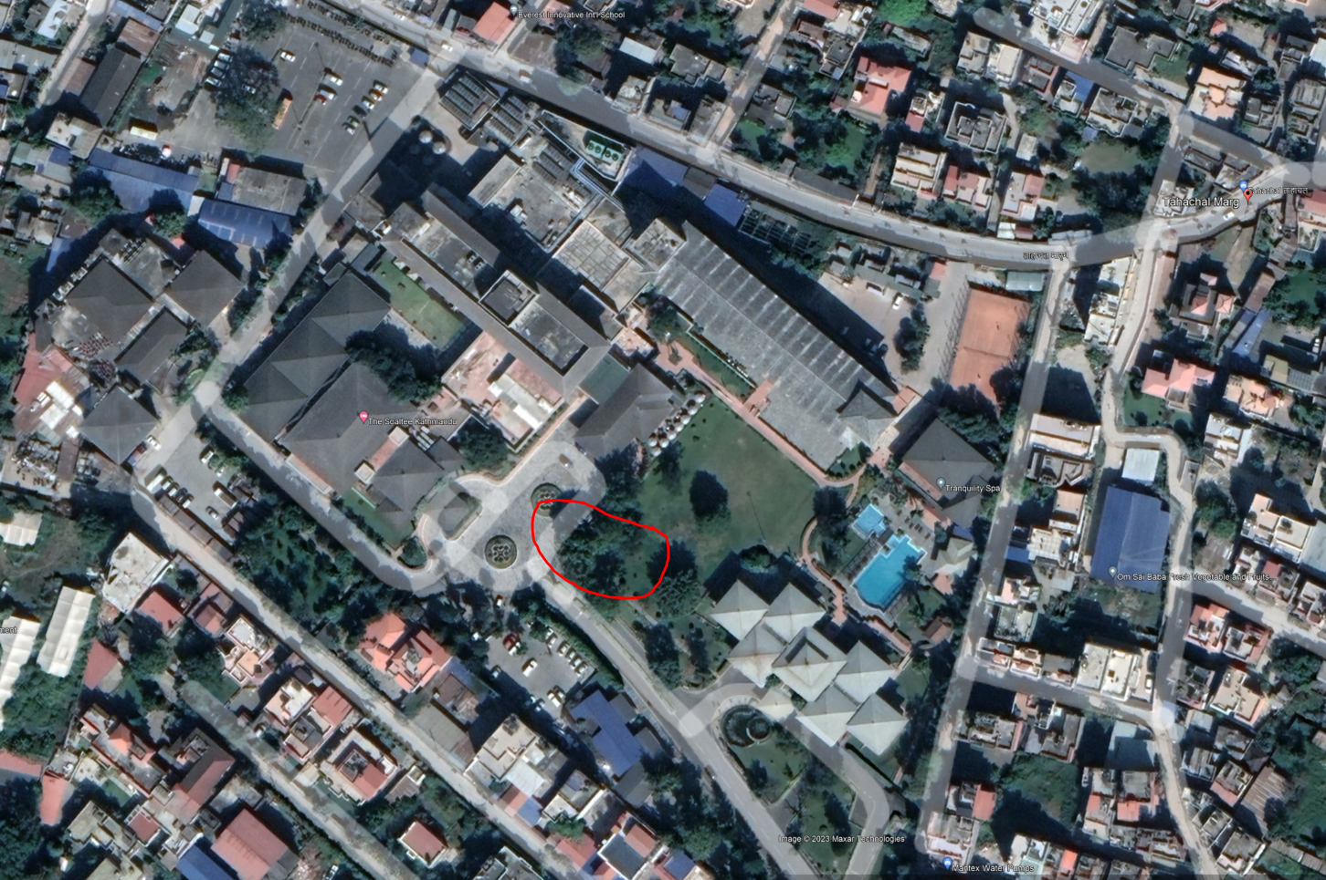

**AFTER THE QUAKE:**

1. Watch out for powerlines, they might still have electricity running.
2. There will be dozens of aftershocks, some as strong as the first quake.

For More information follow these links:

1- DROP, COVER AND HOLD ON: <https://www.shakeout.org/dropcoverholdon/>

2- **Preparedness in Nepal article world nomads:** <https://www.worldnomads.com/travel-safety/southern-asia/nepal/earthquake-safety-in-nepal>

# RISIKOANALYSE KATHMANDU FEBRUAR 2024

|  |  |  |  |  |  |  |
| --- | --- | --- | --- | --- | --- | --- |
| **Hendelse:** | **Type:** | **Sannsynlighet** | **Konsekvens** | **Risiko:** | **Tiltak for å dempe risiko** | **Ansvar:** |
| Sykdom | Lett sykdom: | 3 | 1 | 3 | Lege på/on call hotellet | Norec |
| Alvorlig sykdom: | 1 | 4 | 4 | * Lege på hotellet, kontaktinfo i emergency plan * Nærhet til sjukehus, kontaktinfo i emergencyplan   Tiltaksplan punkt 1. | Partner **&** Norec |
| Ulykker | Reise/transport | 2 | 4 | 8 | Reise til og fra kurssted i regi av Norec regnes som trygt.  Å reise rundt i byen på egenhånd medfører viss risiko i trafikken. Må unngå motorsykkeltaxi, og være svært varsom når man går til fots. Ikke bruk offentlig transport.  Informer deltagere første dag.  Tiltaksplan 3. | Partner & Norec |
| Dødsfall | 1 | 5 | 5 | Sjå emergency plan | Partner **&** Norec |
| Kriminalitet | Grove ran | 1 | 3 | 3 |  | PA **eller** Norec |
| Ran | 1 | 2 | 2 |  |  |
| Kidnapping | 1 | 4 | 4 |  | Partner **&** Norec |
| Vold | 1 | 3 | 3 |  | PA **eller** Norec |
|  | Drap | 1 | 5 | 5 | Sjå emergency plan | Partner **&** Norec |
| Politisk uro | Generell | 1 | 2 | 3 | Relativt stabil politisk situasjon, men sårbar etter konflikt 1996-2006. | Partner **&** Norec |
| Spesifikk | 2 | 2 | 4 | Tidvis demonstrasjoner, sjelden voldelig. | Partner**&** Norec |
| Krigsutbrudd | Varierende | 1 | 5 | 5 | Emergency plan | Partner**&** Norec |
| Terror events |  | 1 | 4 | 4 | Emergency plan. Holde seg oppdatert på nyheter og trusselbilde.   Sannsynlig mot Britiske borgere (UK GOVT) |  |
| Naturkatastrofer | Varierende | 3 | 4 | 12 | Det antas at flere større jordskjelv vil kunne ramme Nepal i fremtiden.  Se tiltaksplan punkt 2.  Gjennomgang av rutiner før avreise, i tillegg til gjennomgang på kursdag 1. | Partner**&**Norec |
| Brann på hotellet |  | 1 | 4 | 5 | Briefing fra hotellet  security plan fire |  |
| Deltagere på avveie |  | 2 | 3 | 6 | Tiltaksnr. 8 |  |

**Handlingsplan**

|  |  |  |  |  |  |  |
| --- | --- | --- | --- | --- | --- | --- |
| **Tiltak nr** | **Sak** | **Tiltak** | **Ansvarlig** | **Tidsfrist** | **Utført** | **Evaluert dato** |
| 1 | Alvorlig sjukdom | * Lege på hotellet, kontaktinfo i emergency plan * Nærhet til sjukehus, kontaktinfo i emergencyplan | Alle |  |  |  |
| 2 | Naturkatastrofer | * Informasjon internt i Norec-teamet om ’dos and donts’ ved jordskjelv * Hotell briefer deltagerne om evakueringsrutiner, samlingsplass, osv. | Andreas / Hotellet | Informasjon første dag.  Test av evakueringsruter/rally points. |  |  |
| 3 | Reise/transport ulykke | * Alle transport i regi av Norec skjer med forhåndsgodkjente selskaper og sjåfører. * Informere deltakere om å være forsiktig i trafikken, og ikkje bruke offentlig transport. * Ta taxi saman | Alle |  |  |  |
| 7 | Brann på hotellet | * Briefing from hotel * security plan fire | Hotel security staff | Ved ankomstmøte og første dag for deltakere |  |  |
| 8 | Missing participants | * Briefing første dag. * Ikke drikk for mye alkohol, ikke gå ut alene. * Husk navnet på hotellet vis man trenger direksjon/taxi hjem igjen. | Alle | Informasjon til deltakere første dag |  |  |
| 9 | Generell politisk uro | * Være oppdatert på nyheter om demonstrasjoner, protester, uro i gatene. * Dialog med ambassade. | Andreas | Kontinuerlig.  Avsjekk med Andrea Silkoset fra ambassaden 29.01. |  |  |

1. **Critical situations**: situations with potential danger to life and/or health. **Serious situations**: situations involving crime, injuries, missing persons etc.